Car Marketplace System

Object-Oriented Programming Assignment 2

Muhammad Zain
Student ID: 25K-0132

Contents
1 Introduction
2 Website Inspiration and Comparison
2.1 Homepage Listing Layout
2.2 Search and Filter System
2.3 User Messaging System
3 Classes Implemented
4 Constructors and Design Decisions
4.1 Parameterized Constructors
4.2 Copy Constructors
4.3 Destructor
5 Abstract Interfaces
6 Inheritance Relationships
7 Polymorphism
8 Operator Overloading
9 Friend Functions and Friend Classes
10 Constants and Constant Functions
11 Static Members
12 Composition and Aggregation
13 Array of Objects
14 System Functionalities
15 Class Diagram
16 Important Code Snippets and Reasoning
17 Conclusion

1 Introduction
This project is a Car Marketplace System inspired by PakWheels. The system is designed using Object-Oriented Programming (OOP) principles in C++, extended from Assignment 1 to incorporate advanced OOP concepts.

The goal of this assignment is to demonstrate understanding of:
- Classes and Objects
- Constructors and Destructors
- Inheritance and Polymorphism
- Abstraction through Pure Virtual Interfaces
- Operator Overloading
- Friend Functions and Friend Classes
- Static Members
- Constants and Constant Functions
- Composition and Aggregation
- Dynamic Arrays (Array of Objects)

The system allows users to:
- Register as Buyer, Seller, or Admin
- Post vehicle listings (Car or Bike)
- Search and filter listings
- Save favourite listings
- Send messages
- Approve or remove listings (Admin)

2 Website Inspiration and Comparison
This system is inspired by PakWheels (www.pakwheels.com).

2.1 Homepage Listing Layout
The listing display structure in this system replicates the following elements from PakWheels:
- Vehicle brand and model
- Price display
- Location
- Vehicle specifications
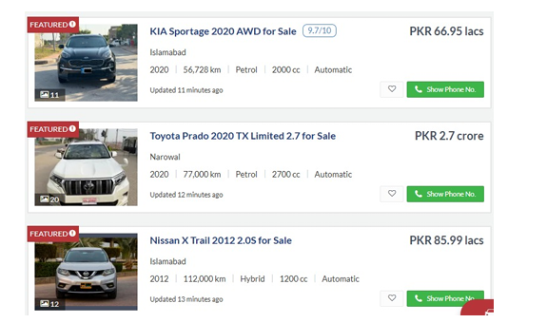
PakWheels Listing Screenshot

2.2 Search and Filter System
Similar to PakWheels, this system provides filtering based on:
- Brand
- Model
- Price range
- Year
- Mileage

The filtering logic is implemented in the filterSearchResults() function inside the Marketplace class.

2.3 User Messaging System
The messaging feature replicates the buyer-seller communication system used on PakWheels. Users can send and receive messages stored dynamically in the inbox array.

3 Classes Implemented
The system contains the following 16 classes:

Abstract Interfaces (4)
- IDisplayable
- ISearchable
- IReportable
- IVerifiable

Concrete Classes (12)
- Vehicle
- Car (extends Vehicle)
- Bike (extends Vehicle)
- Account
- Seller (extends Account)
- Buyer (extends Account)
- Admin (extends Account)
- Listing
- Message
- Review
- InspectionReport
- Marketplace

Each class contains 5-6 data members and at least 4 member functions (excluding getters and setters).

4 Constructors and Design Decisions

4.1 Parameterized Constructors
Parameterized constructors are used to ensure that objects are initialized with meaningful values at the time of creation.

Example:
- Vehicle requires brand, model, year, mileage, colour, and transmission.
- Car additionally requires doors, fuelType, and engineCC.
- Bike additionally requires bikeType, hasFairing, and engineCC.
- Listing requires price, location, description, and seller.

This prevents incomplete objects from existing in the system.

4.2 Copy Constructors
Copy constructors are implemented in:
- Account
- Seller
- Buyer

They are required because these classes contain dynamic memory (pointer arrays). Without a copy constructor, shallow copying would cause memory issues such as double deletion.

4.3 Destructor
A virtual destructor is used in the Account class to ensure proper deletion of derived objects (Seller, Buyer, Admin). This prevents memory leaks when deleting objects using base class pointers.

5 Abstract Interfaces
Four abstract base classes (interfaces) are defined with pure virtual functions. They hide implementation details and expose only essential features, fulfilling the Abstraction requirement.

IDisplayable
- Pure virtual: displayDetails() const = 0
- Any entity that can display itself. Implemented by Vehicle, Message, Review, Account, Listing, InspectionReport.

ISearchable
- Pure virtual: matchesQuery(const string&) const = 0
- Any entity that supports keyword-based searching. Implemented by Vehicle and Listing.

IReportable
- Pure virtual: generateReport() const = 0
- Any entity that can produce a formatted report. Implemented by InspectionReport and Marketplace.

IVerifiable
- Pure virtual: verify() const = 0
- Any entity that supports a verification step. Implemented by Account, Seller, Buyer, and Admin.

Separate header (.h-style) interface comments are provided in the code above each abstract class definition to document the interface contract.

6 Inheritance Relationships
The system implements 16 inheritance relationships, exceeding the required 10-12. Each relationship is justified below.

# | Derived Class | Base Classes | Justification
1 | Vehicle | IDisplayable | Vehicle can display its specs
2 | Vehicle | ISearchable | Vehicle can be searched by brand/model
3 | Message | IDisplayable | Messages are displayed in inbox
4 | Review | IDisplayable | Reviews are displayed on seller profiles
5 | Account | IDisplayable | All accounts can display their details
6 | Account | IVerifiable | Accounts need email/ban verification
7 | Listing | IDisplayable | Listings are displayed in search results
8 | Listing | ISearchable | Listings are matched by keyword/location
9 | Seller | Account | Seller IS-A Account with extra seller features
10 | Buyer | Account | Buyer IS-A Account with favourite listings
11 | Admin | Account | Admin IS-A Account with moderation powers
12 | Car | Vehicle | Car IS-A Vehicle with engine, doors, fuel info
13 | Bike | Vehicle | Bike IS-A Vehicle with bike-specific attributes
14 | InspectionReport | IReportable | Reports generate formatted output
15 | InspectionReport | IDisplayable | Reports can also be displayed inline
16 | Marketplace | IReportable | Platform generates a summary report

7 Polymorphism
Polymorphism is achieved through function overriding of virtual functions. The displayDetails() function is declared virtual in Account and Vehicle and overridden in every derived class.

Function Overriding Examples:
- Account::displayDetails() — base version shows generic login info.
- Seller::displayDetails() — overrides to show rating, city, contact method.
- Buyer::displayDetails() — overrides to show city, member since, verified status.
- Admin::displayDetails() — overrides to show department, level, actions taken.
- Vehicle::displayDetails() — base version shows brand, model, year, etc.
- Car::displayDetails() — calls Vehicle::displayDetails() then adds doors, fuelType, engineCC.
- Bike::displayDetails() — calls Vehicle::displayDetails() then adds bikeType, engineCC, fairing.

In main(), an Account* array holds pointers to Seller, Buyer, and Admin objects. Calling users[i]->displayDetails() dispatches to the correct override at runtime, demonstrating runtime polymorphism.

8 Operator Overloading
Operators are overloaded in 12 classes. Both member functions and global friend functions are used. Each overload is justified below.

Class | Operators | Justification
Vehicle | ==, <<, >> | == checks same brand/model/year; << prints summary; >> reads from cin
Message | ==, << | == compares content equality; << prints message summary
Review | ==, >, <, << | Compare ratings; << prints review inline
Account | ==, << | == checks accountId; << prints account summary
Listing | ==, <, >, +, <<, >> | == checks id; <> compares price; + combines prices; <</>> for I/O
Seller | ==, >, <, << | == checks id; >, < compare sellerRating; << prints seller summary
Buyer | ==, +, << | == checks id; + merges favourite counts; << prints buyer summary
Admin | ==, >, << | == checks id; > compares actionsTaken; << prints admin summary
Car | ==, << | == checks brand+model+engineCC; << prints car summary
Bike | ==, << | == checks brand+model+engineCC; << prints bike summary
InspectionReport | ==, >, <, << | Compare overall scores; << prints report inline
Marketplace | + (member), << | + posts a listing (syntactic sugar); << prints platform summary

Operators overloaded as member functions: ==, <, >, + in most classes. Operators overloaded as global friend functions: << (stream insertion) and >> (stream extraction) in Vehicle and Listing, providing natural I/O syntax.

9 Friend Functions and Friend Classes
Friend functions and friend classes are used when external access to private members is genuinely necessary and cannot be achieved through the public interface without compromising encapsulation design.

Friend Functions implemented:

comparePrices(const Listing&, const Listing&)
A global utility function that compares the private price and listingId of two Listing objects simultaneously. Declared as friend inside Listing. Justification: requires simultaneous read access to two objects' private fields; using only getters would be sufficient here but the friend version illustrates direct private member access.

compareSellerRatings(const Seller&, const Seller&)
A global utility function that compares private sellerRating and protected firstName of two Seller objects. Declared as friend inside both Seller and Account. Justification: needs access to private sellerRating (not publicly settable) and protected firstName from the Account base class.

operator<<(ostream&, const Seller&)
Global stream-insertion operator for Seller. Declared friend to access private sellerRating and city. Justification: operator<< must be non-member for natural cout << seller syntax, but still needs private data.

friend class Marketplace (inside Listing)
Marketplace is declared a friend class of Listing. Justification: Marketplace manages the lifecycle of all listings and needs direct internal access to listingId and status for efficient moderation operations without exposing public setters.

10 Constants and Constant Functions
The program uses constant data members such as:
- Platform_Name (= "PakWheels")
- Max_Listings_Per_User (= 10)

Constant member functions are used in multiple classes (e.g., display functions and getter functions). These functions are marked as const to ensure they do not modify object state.

Constants are used to:
- Protect system rules (e.g., maximum listings allowed)
- Prevent accidental modification
- Improve program safety

11 Static Members
Static data members are used to maintain shared counters:
- totalAccountsCreated
- totalListings
- totalMessages
- totalReviews
- totalReports

These members are static because:
- They belong to the class, not individual objects
- They maintain unique ID generation
- They track system-wide statistics

Static members ensure that every new object receives a unique identifier.

12 Composition and Aggregation

12.1 Composition Relationships
- Listing contains a Vehicle object (strong ownership).
- Seller owns Review objects and deletes them in destructor.
- Car and Bike are composed into a Listing via the Vehicle reference.

In composition, if the parent object is destroyed, the contained objects are also destroyed.

12.2 Aggregation Relationships
- Listing has a pointer to Seller (Account*).
- Message references sender and receiver (Account*).

In aggregation, objects can exist independently of each other.

13 Array of Objects
Dynamic arrays are used in:
- Marketplace (array of Listing and Account pointers)
- Seller (array of Review pointers)
- Buyer (array of favourite Listing pointers)
- Account (array of Message pointers)

Arrays are resized dynamically by creating new arrays and copying existing elements. This demonstrates understanding of memory management.

14 System Functionalities
The system supports the following features:

14.1 Listing Management
- Add listing
- Update listing price
- Delete listing
- Admin approval and removal

14.2 Search and Filter
Users can search by:
- Brand
- Model
- Price range
- Year
- Mileage
- Location

14.3 Buyer Features
- Save favourite listings
- Remove from favourites
- Send messages to sellers

14.4 Seller Features
- Post listings
- Receive reviews
- Track rating

14.5 Admin Features
- Approve listings
- Remove listings
- Ban user accounts

15 Class Diagram
(diagram on last page)

The class diagram shows:
- Abstract interfaces (IDisplayable, ISearchable, IReportable, IVerifiable)
- Inheritance: Account -> Seller, Buyer, Admin; Vehicle -> Car, Bike
- All classes implementing abstract interfaces
- Composition relationships
- Aggregation relationships
- Data members and member functions
- Operator overloads and friend functions indicated

16 Important Code Snippets and Reasoning

16.1 Abstract Interface Usage
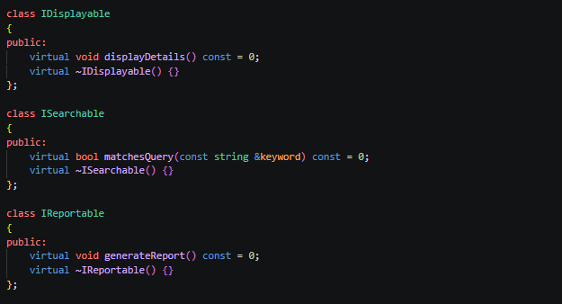
Reason: Pure virtual functions define a contract that all displayable classes must fulfil. This enforces a consistent interface and enables polymorphic display through IDisplayable* pointers.

16.2 Inheritance Example
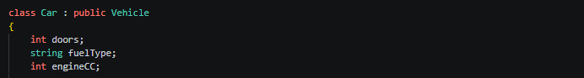
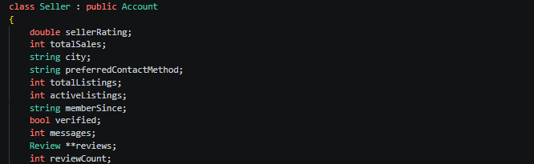
Reason: Car “is-a” Vehicle; Seller “is-a” Account. Inheritance avoids code duplication and allows substitution through base-class pointers.

16.3 Polymorphism Example
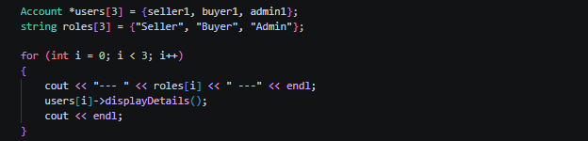Reason: The correct displayDetails() is resolved at runtime via the vtable, demonstrating dynamic dispatch — the core of polymorphism.

16.4 Operator Overloading Example
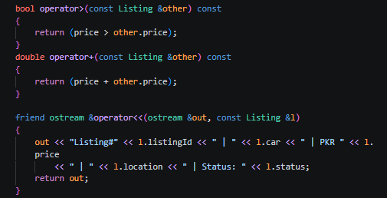
Reason: Operator overloading provides natural, readable syntax for comparing and printing objects. Member operators access this object's private data; friend operators enable cout << obj syntax.

16.5 Friend Function Example
// Global friend function - accesses private price and listingId
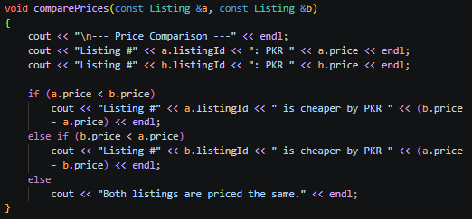
Reason: The function needs simultaneous read access to private members of two Listing objects. Declaring it friend grants this access without exposing public setters or compromising the overall encapsulation of the class.

17 Conclusion
This project successfully extends the Car Marketplace System from Assignment 1 using advanced Object-Oriented Programming principles in C++.

It demonstrates:
- Strong class design with 16 classes
- 16 Inheritance relationships with clear justification
- Runtime Polymorphism through virtual function overriding
- Abstraction through 4 pure-virtual interface classes
- Operator Overloading in 12 classes using both member and friend forms
- Friend Functions and Friend Classes with justified use cases
- Static member usage for unique ID generation
- Composition and aggregation relationships
- Dynamic memory management
- Real-world system modelling inspired by PakWheels

The system reflects a simplified but comprehensive version of a real-world platform similar to PakWheels and fulfils all Assignment 2 requirements.

Figure 2: Class Diagram of Car Marketplace System

Abstract Interfaces:

<<abstract>> IDisplayable  + displayDetails() const = 0 | <<abstract>> ISearchable  + matchesQuery(keyword) const = 0 | <<abstract>> IReportable  + generateReport() const = 0 | <<abstract>> IVerifiable  + verify() const = 0
Account  # email : string  # encryptedpassword : string  # phone : string  # firstName : string  # lastName : string  # accountId : int  # isBanned : bool  # inbox : Message**  o totalAccountsCreated : int  + authenticate()  + setPassword()  + displayDetails() override  + verify() override  + operator==  + friend operator<< | Vehicle  - brand : string  - model : string  - year : int  - mileage : int  - colour : string  - transmission : string  + displayDetails() override  + matchesQuery() override  + isEligibleForInspection()  + updateMileage()  + operator==  + friend operator<<  + friend operator>> | Seller  - sellerRating : double  - totalSales : int  - city : string  - verified : bool  - reviews : Review**  + addReview()  + displayDetails() override  + verify() override  + operator>, <, ==  + friend operator<< | Buyer  - favourites : Listing**  - favouritesT : int  - city : string  - verified : bool  + addToFavourites()  + removeFromFavourites()  + displayDetails() override  + verify() override  + operator==, +  + friend operator<<
Admin  - adminLevel : int  - department : string  - actionsTaken : int  - canManageAdmins : bool  + approveListing()  + removeListing()  + banUserAccount()  + displayDetails() override  + verify() override  + operator==, > | Car  - doors : int  - fuelType : string  - engineCC : int  + displayDetails() override  + operator==  + friend operator<< | Bike  - bikeType : string  - hasFairing : bool  - engineCC : int  + displayDetails() override  + operator==  + friend operator<< | Listing  - listingId : int  - price : double  - location : string  - status : string  - car : Vehicle  o totalListings : int  + approve()  + displayDetails() override  + matchesQuery() override  + operator==, <, >, +  + friend operator<<, >>  + friend comparePrices()  + friend class Marketplace
Message  - messageId : int  - content : string  - timestamp : string  - isRead : bool  o totalMessages : int  + markAsRead()  + displayDetails() override  + operator==  + friend operator<< | Review  - reviewId : int  - rating : double  - comment : string  - helpfulVotes : int  o totalReviews : int  + addHelpfulVote()  + displayDetails() override  + operator==, >, <  + friend operator<< | InspectionReport  - reportId : int  - engineScore : int  - exteriorScore : int  - interiorScore : int  - suspensionScore : int  o totalReports : int  + getOverallScore()  + isCertified()  + generateReport() override  + displayDetails() override  + operator==, >, <  + friend operator<< | Marketplace  - users : Account**  - userCount : int  - listings : Listing**  - listingCount : int  o PLATFORM_NAME : string  o MAX_LISTINGS_PER_USER  + registerAccount()  + postListing()  + searchListings()  + filterSearchResults()  + generateReport() override  + operator+  + friend operator<<
Blue headers = concrete classes. Purple headers = abstract interfaces. o = static.

